Legio XIIII Gemina  
  
  
**Legionaries**Handbook  


A Legio XIIII Guide: Legionary Kit

This guide will allow beginners to start their impression as a first century Roman Legionary.

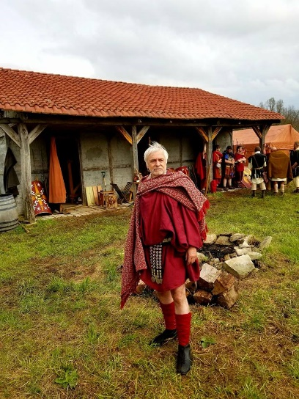 **Tier 1: Soft Kit**

*It is strongly advised that new recruits start with their soft kit first, because it is essential in order for armor to fit properly.*

**Required items:**

* Tunic
* Caligae
* Balteus
* Sagum or Paenula
* Fibula
* Optional: Braccae, Udones (Socks)
* Focale

**Tunic**

*The tunicae of the Roman Legionary could be made of linen, wool, or he could have one of each. Linen is more common during the warmer seasons, and can be layered during the winter.*

**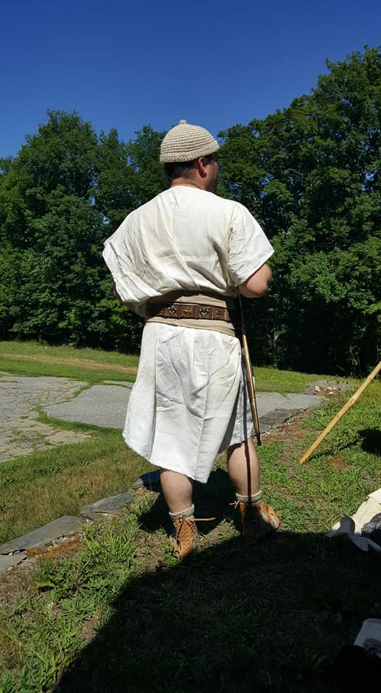

The Tunica can either be purchased form a recommended Vendor, or made by the individual. The cost of a purchase is between $75 and $120. If you prefer to make one, we have provided the following guide:

* **Materials Needed**: $40-58+shipping
  + 3-4 yards natural linen: $30-$40+shipping (Can also be found at local fabric stores).
    - <https://fabrics-store.com/fabrics/linen-fabric-IL019-natural-middle/>
    - Subdued earth tones (brown, green, ochre, etc) are also acceptable.
    - Blue should be light blue, to mimic woad-based dyes.
    - Discount Code: ILOVELINEN
  + OR 3-4 yards natural wool: $36-48+shipping.
    - <https://96fabrics.vendecommerce.com/p/tan-wool>
    - Subdued earth tones (brown, green, ochre, etc) are also acceptable.
    - Blue should be light blue, to mimic woad-based dyes.
  + Needle Pack: $3.99+shipping
    - <https://www.tandyleather.com/en/product/stitching-needles>
  + Linen Thread: $6.99+shipping
    - <https://www.tandyleather.com/en/product/unwaxed-linen-thread-natural>
  + NOTES:
    - Please use the pattern below:
    - We prefer you hand stitch your garments. The thickness of linen thread makes them more resistant to tears than machine thread.
      * You may use a sewing machine if you want, but please use a straight stitch.
    - Tunics should be baggy, so measure yourself first! We usually do 48” x 48”, with 12” holes for head and arms.
    - Regarding how to determine the size for your Military Tunic.
      * A 'Best Practice' which keeps the proportion, size, drape and wear as close as possible to historically accurate, is this:
        + 1. With arms held up, and out to your sides, wrist level with your shoulders. Measure the distance from about 2 inches past one elbow, across your chest, and over to the same distance beyond the other elbow. This will be your width
        + 2. Measure from the top of your collar bone, down your chest and stomach to a distance 2 inches below your knee. This will be your length. - You will lose one inch on each measurement after you fold and sew the edges.
        + - An option is to simply measure the length only, and also take that measurement as the width, making a true square tunic.
        + - These methods will help accommodate the tall or very large chested (or big bellied) as well as the thin or short person, while keeping the tunic in proportion for their body size.

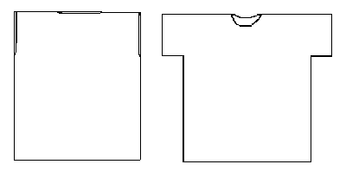

**Braccae**

*Though trousers considered effeminate by the Romans, the shorter braccae were acceptable for colder climates. These could be made of wool, linen, or leather.*

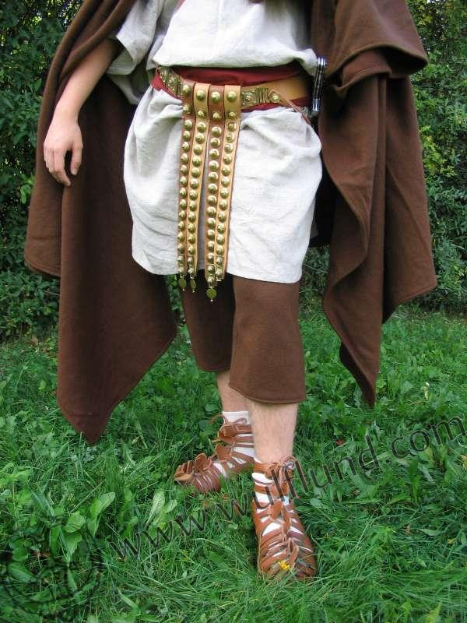

* **Materials Needed**: $20-34+shipping
  + 1-2 yards natural linen: $10-$20+shipping.
    - <https://fabrics-store.com/fabrics/linen-fabric-IL019-natural-middle/>
    - Subdued earth tones (brown, green, ochre, etc) are also acceptable.
    - Blue should be light blue, to mimic woad-based dyes.
    - Discount Code: ILOVELINEN
  + OR 1-2 yards natural wool: $12-24+shipping.
    - <https://96fabrics.vendecommerce.com/p/tan-wool>
    - Subdued earth tones (brown, green, ochre, etc) are also acceptable.
    - Blue should be light blue, to mimic woad-based dyes.
  + Needle Pack: $3.99+shipping
    - <https://www.tandyleather.com/en/product/stitching-needles>
  + Linen Thread: $6.99+shipping
    - <https://www.tandyleather.com/en/product/unwaxed-linen-thread-natural>
  + NOTES:
    - Please use the pattern below:
    - We prefer you hand stitch your garments. The thickness of linen thread makes them more resistant to tears than machine thread.
      * You may use a sewing machine if you want, but please use a straight stitch.

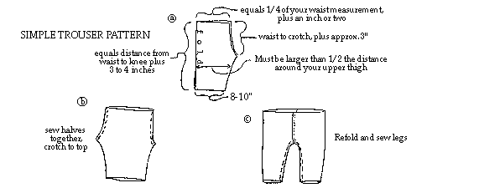

**Caligae**

*Necessary for maneuvering through the forests of Germania, every able-bodied warrior needs a trusty pair of shoes.*

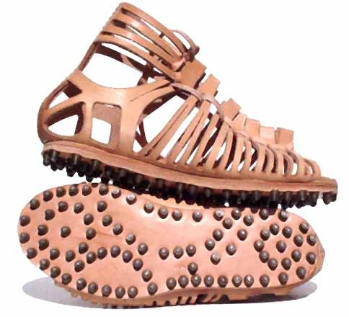

* **Materials Needed**: $80+shipping (Not including hobnails due to varying prices)
  + 4-5oz Leather: $69.99+shipping
    - <https://www.etsy.com/listing/590755349/genuine-vegetable-tan-cowhide-shoulder?gpla=1&gao=1&&utm_source=google&utm_medium=cpc&utm_campaign=shopping_us_a-craft_supplies_and_tools-raw_materials-leather&utm_custom1=29ce1667-4faa-41fe-a97a-1f1bda515153&gclid=CjwKCAjwp7baBRBIEiwAPtjwxFitW3m0WetQQcGYVjvJ5t270Jgk2jQ-BAEET3no7K5SixgC4g99IxoCehcQAvD_BwE>
  + Needle Pack: $3.99+shipping
    - <https://www.tandyleather.com/en/product/stitching-needles>
  + Linen Thread: $6.99+shipping
    - <https://www.tandyleather.com/en/product/unwaxed-linen-thread-natural>
  + Hobnails:
    - Please contact Jason R Young on Facebook for prices on loose hobnails.
  + NOTES:
    - Please use the pattern below.
    - It is not necessary for you to buy a needle/thread set for each listing. This just lists what you need to craft the item and its cost, but you get a lot of needles and thread per order.
    - **You can also purchase** Roman Caligae from Rusty Arthur on Facebook, who runs Soul of the Warrior. Pre-made caligae tend to come rather large, so order 1-2 sizes below your shoe size.

Roman Caligae:

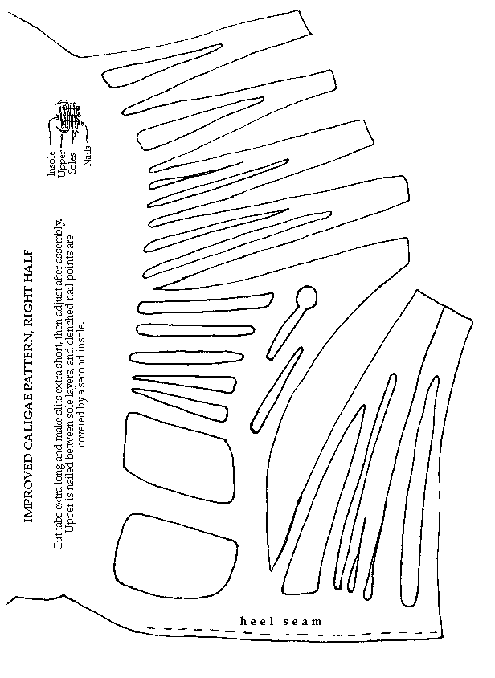

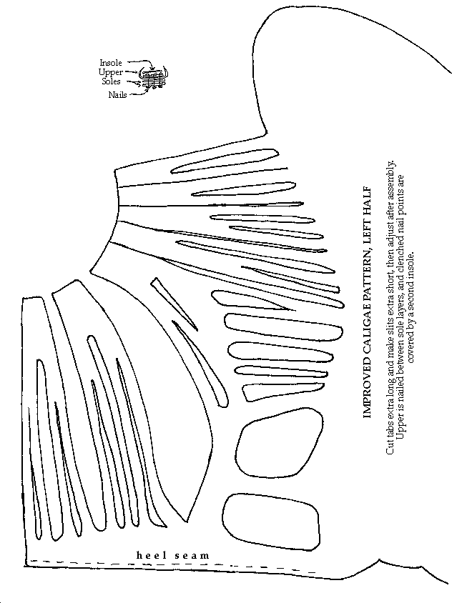

**Balteus**

*The status symbol of all Roman soldiers, many denarii went into stylizing the Balteus. It was the key piece of military fashion during the first century.*

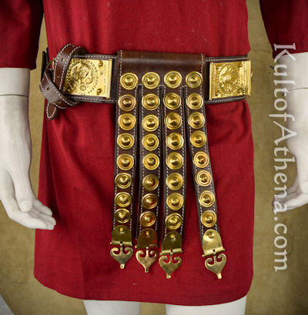

* Purchase here: <http://www.kultofathena.com/product.asp?item=AH6797&name=Roman+Cingulum+Belt+-+%27%27She-Wolf%27%27+with+Romulus+and+Remus>
* A simpler version of this can be made with a belt buckle and a leather strap (50” x 1.5”) from Trinity Armory (Contact Jason R. Young)

**Sagum or Paenula**

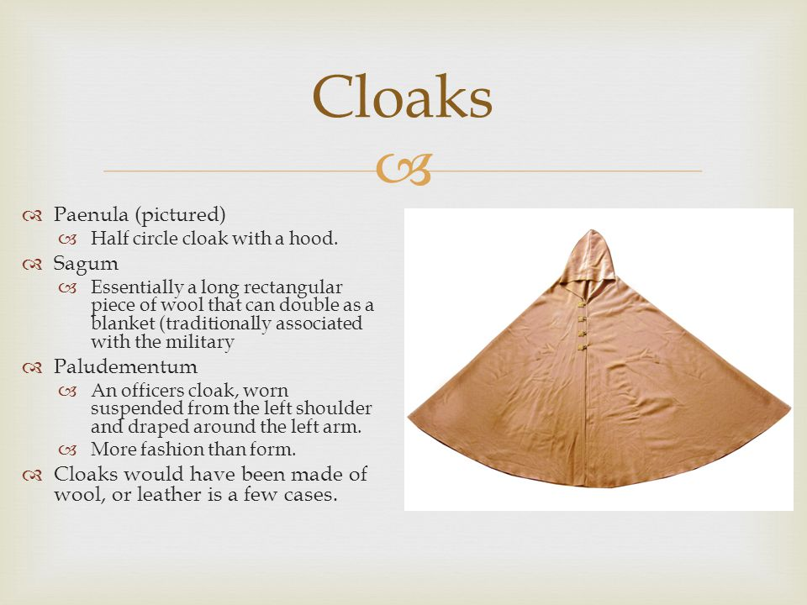



* **Materials Needed:**
  + 4 yards natural wool: $60+shipping.
    - <http://www.96fabrics.net/products/dark-brown-wool>
    - Subdued earth tones (brown, green, ochre, etc) are also acceptable.
    - Blue should be light blue, to mimic woad-based dyes.
  + For higher quality cloaks, use Fabrica Cacti.
    - <https://www.facebook.com/FabricaCacti/>

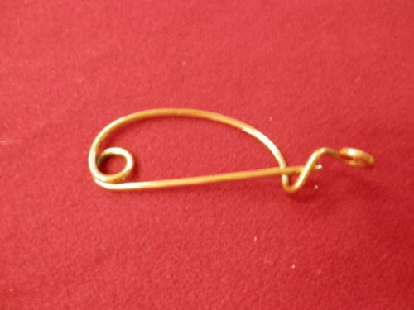**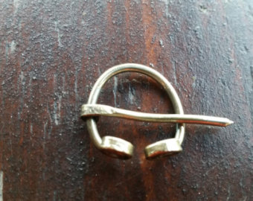Fibula**

* Sold on Soul of the Warrior’s Ebay Page: <https://www.ebay.com/itm/Ancient-Reenactor-Pin-Fibulae-blanket-pin/232850213929>

**Focale (scarf)**

In the most simple terms, a Focale is a Linen, Cotton or Wool (not knitted wool) scarf, worn around the neck to reduce friction of the armor on the neck.

The length and width of the Focale should be approximately 12”x 36”, and is easily made with remnants form making a tunic, or form other purchased cloth.

**Udones (socks)**

Knit socks. Naalbinding is the most correct style of knitting used to make the socks. Alternately, using linen or cotton to make a foot wrap is also an option.

Etsy is a great source for Naalbinding items. Expect to pay a minimum of $40.00 for a pair of Nallbinding socks.

**Tier 2: Armor**

*The gear listed in Tier 2 is essential for completing the basic look of the Roman Legionary.*

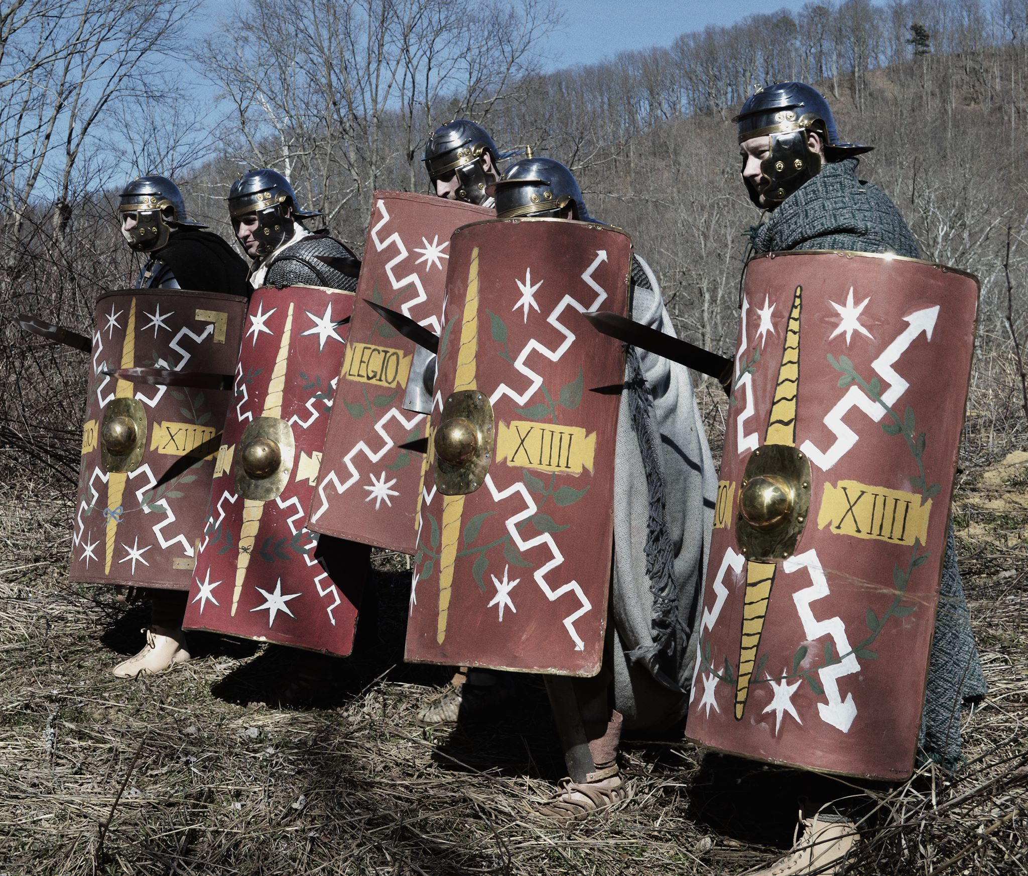

**Required items:**

* Scutum
* Helmet
* Subarmalis
* Hamata OR Segmentata OR Squamata

**Scutum (Curved Rectangle):**

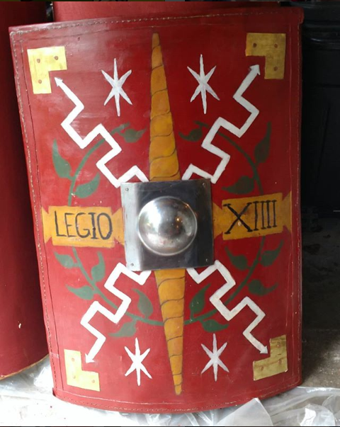

* **Materials Needed**: $115+shipping
  + 2 Sheets Baltic Birch Plywood: $18.50+shipping.
    - <https://www.woodcraft.com/products/baltic-birch-plywood-3mm-1-8-x-30-x-48>
  + 2 yards natural linen: $20+shipping.
    - <https://fabrics-store.com/fabrics/linen-fabric-IL019-natural-middle/>
    - Subdued earth tones (brown, green, ochre, etc) are also acceptable.
    - Blue should be light blue, to mimic woad-based dyes.
    - Discount Code: ILOVELINEN
  + Shield Boss: $19.46+shipping
    - <http://www.kultofathena.com/product.asp?item=SNS2196&name=Square+Shield+Boss+-+16+Gauge>
  + Rawhide Dog Bone: $5.59+shipping
    - <https://www.chewy.com/pure-simple-pet-flat-knotted-rawhide/dp/154808>
  + Copper Nails: $12.06+shipping
    - <https://www.amazon.com/Hillman-Fastener-Corp-42081-Copper/dp/B000RMRQA8/ref=sr_1_4?s=hi&ie=UTF8&qid=1531880248&sr=1-4&keywords=copper+nails>
  + Needle Pack: $3.99+shipping
    - <https://www.tandyleather.com/en/product/stitching-needles>
  + Linen Thread: $6.99+shipping
    - <https://www.tandyleather.com/en/product/unwaxed-linen-thread-natural>
  + Wood Glue: $9.99+shipping
    - <https://www.amazon.com/Titebond-Premium-Water-Resistant-Wood/dp/B001DSZ2RY/ref=sr_1_2?s=hi&ie=UTF8&qid=1531880327&sr=1-2&keywords=titebond+wood+glue>
  + NOTES:
    - Please use the guide below.
    - It is not necessary for you to buy a needle/thread set for each listing. This just lists what you need to craft the item and its cost, but you get a lot of needles and thread per order.
    - You can also make a rectangle with curved edges, or a curved oval shape. These are alternative designs not common among reenactors, but were common during the first century AD.
* **Scutum Construction Guide**
  + Please follow Legio XX’s comprehensive guide on how to make a scutum, linked here: <https://www.larp.com/legioxx/scutum.html>

**Helmet**

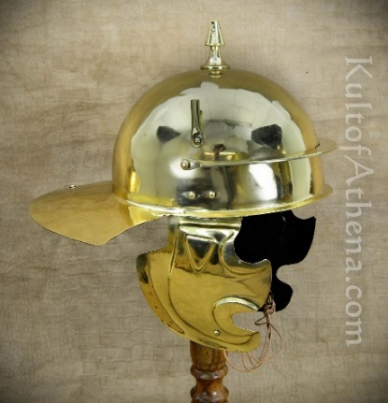 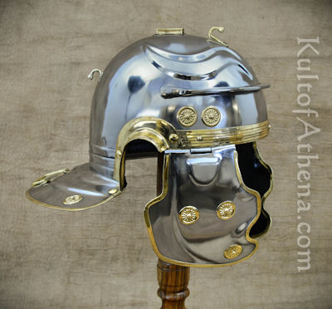 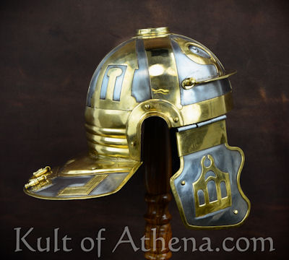

* Coolus G Helmet
  + http://www.kultofathena.com/product.asp?item=AH6308N&name=Roman+Coolus+%27%27G%27%27+Helm+-+18+Gauge
* Gallic G Helmet
  + <http://www.kultofathena.com/product.asp?item=AH6052N&name=Imperial+Roman+Gallic+G+Helm+-+18+Gauge>
* Italic D Helmet
  + <http://www.kultofathena.com/product.asp?item=AH6054K&name=Roman+Italic+%27%27D%27%27+Helm+-+Krefeld+-18+Gauge>
* Notes:
  + Acceptable Helmet Ranges:
    - Gallic: A, B, C, D, E, F, G, H
    - Italic: A, B, C, D
    - Coolus: G

**Subarmalis**

*Whether a uniquely crafted garment or a patchwork of old linen and wool, padding is essential for most armors.*

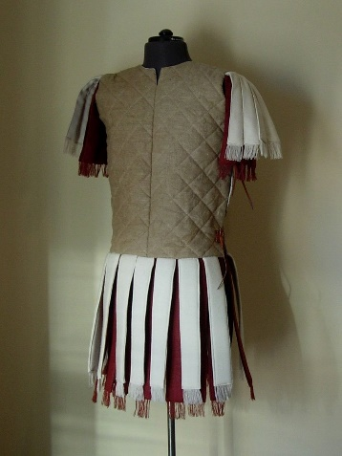 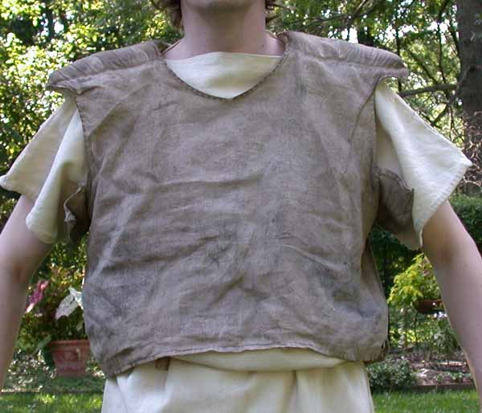

* **Materials Needed:**
  + $48+shipping
    - 2 yards natural linen: $20+shipping.
      * <https://fabrics-store.com/fabrics/linen-fabric-IL019-natural-middle/>
      * Subdued earth tones (brown, green, ochre, etc) are also acceptable.
      * Blue should be light blue, to mimic woad-based dyes.
      * Discount Code: ILOVELINEN
    - 1 yard wool felt: $17.49+shipping.
      * <https://www.joann.com/wool-felt-fabric-36-natural/8020372.html>
    - Needle Pack: $3.99+shipping
      * <https://www.tandyleather.com/en/product/stitching-needles>
    - Linen Thread: $6.99+shipping
      * <https://www.tandyleather.com/en/product/unwaxed-linen-thread-natural>
    - NOTES:
      * Please use the guide below:
      * We prefer you hand stitch your garments. The thickness of linen thread makes them more resistant to tears than machine thread.
        + You may use a sewing machine if you want, but please use a straight stitch.
* **Subarmalis Guide:**
  + <https://www.larp.com/legioxx/subarm.html>

**Lorica Segmentata**

*The iconic armor of the Roman Legionary, the Lorica Segmentata was expensive to maintain, but offered superior protection for its time. It was an armor without equal, as long as you could maintain it!*

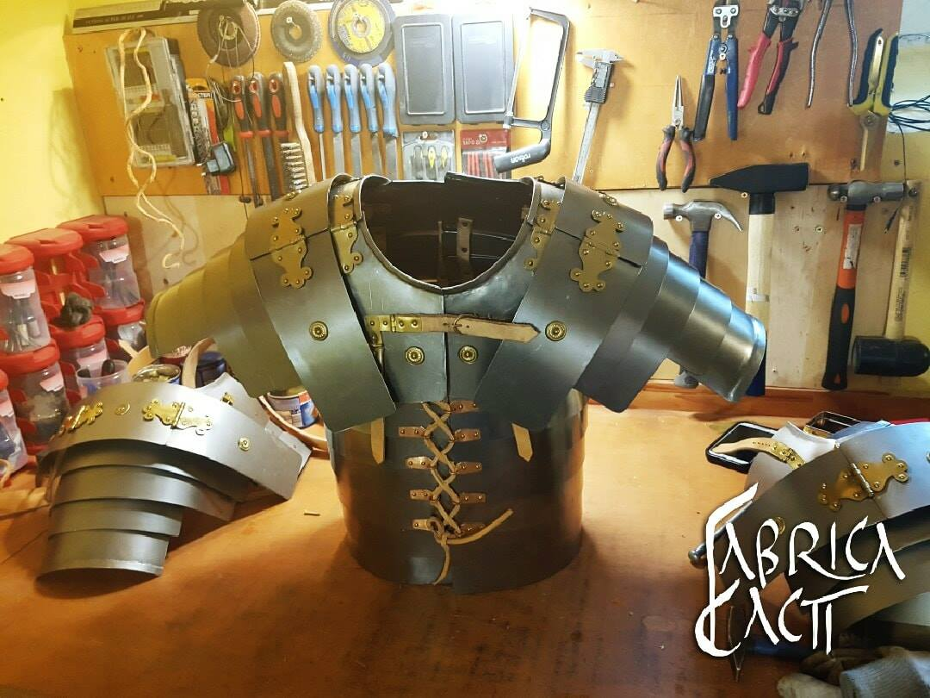

* All orders for Segmentata Should come from Fabrica Cacti:
  + <https://www.facebook.com/FabricaCacti/>
* Deepeeka also makes a segmentata, which is acceptable, but we prefer you get your segmentatae from Fabrica Cacti. It’s slightly more expensive, but for a custom fit, which matters for plate armors.

**Lorica Hamata**

*The most widespread battle armor of the Iron Age, and into the Middle Ages after, maille proves impervious to cut and thrust alike. The envy of every ancient man.*

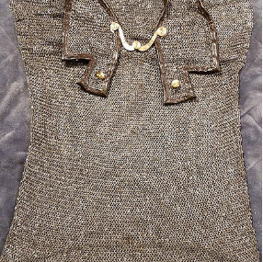

* Contact Jason R Young on Facebook and tell him that you are with Legion 14.
* NOTES:
  + Ring diameter **must** be 6mm. We get a steep discount through Jason Young for 6mm maille, so there is no excuse not to have it.
    - If you have maille with wider ring diameter, we will not turn you away, as long as you are open to eventually replacing it.
  + The chest size of the hamata must be 10” greater than your actual chest size.

**Lorica Squamata**

*An older pattern, hearkening back to the ages of Bronze, Scale shirts are still proven battle armor, able to see the bearer to the end of a fight unharmed.*

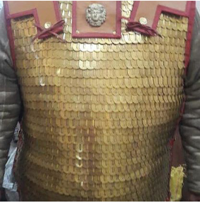

* Contact Jason R Young on Facebook and tell him that you are with Legion 14.

**Tier 3: Weapons**

*The gear listed in Tier 3 is essential for completing the basic look of the Roman Legionary.*

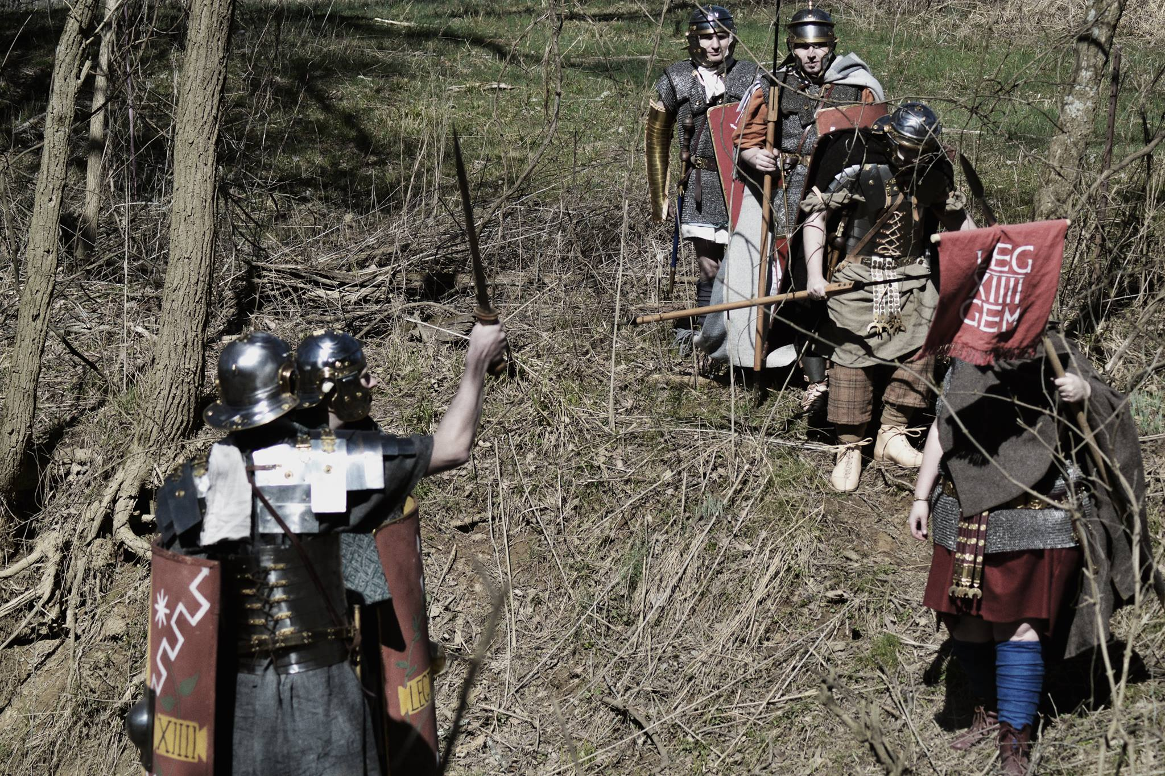

**Required items:**

* Gladius
* Pugio
* 1-2 Pila

**Gladius**

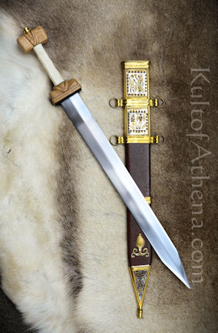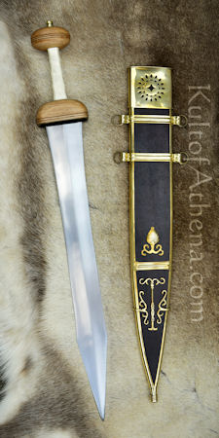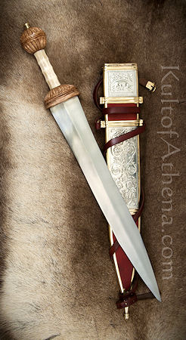

* Pompeii Gladius
  + <http://www.kultofathena.com/product.asp?item=AH4204&name=Titus+Vespasianus+Gladius>
* Mainz Gladius
  + <http://www.kultofathena.com/product.asp?item=AH4209A&name=Legionary+Mainz+Gladius>
* Fulham Gladius
  + <http://www.kultofathena.com/product.asp?item=AH2007&name=Fulham+Gladius>

**Pugio**

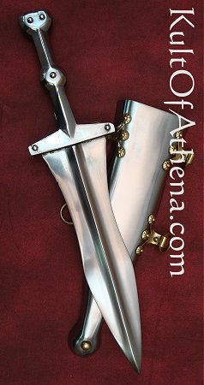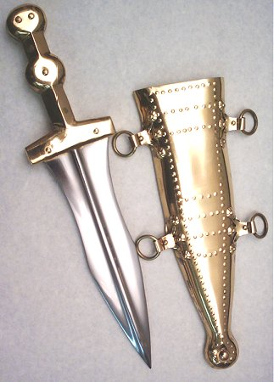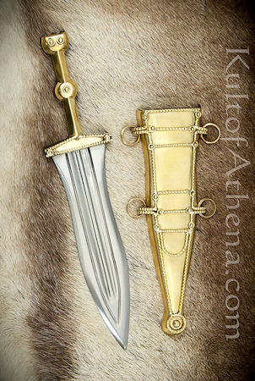

* Plain Pugio
  + <http://www.kultofathena.com/product.asp?item=AH3264P&name=Roman+Pugio>
* Brass Beaded Pugio
  + <http://www.kultofathena.com/product.asp?item=AH3264B&name=Brass+Beaded+Roman+Pugio>
* Leeuwen Pugio
  + <http://www.kultofathena.com/product.asp?item=AH3264A&name=Leeuwen+Pugio+Dagger>

**Pilum**

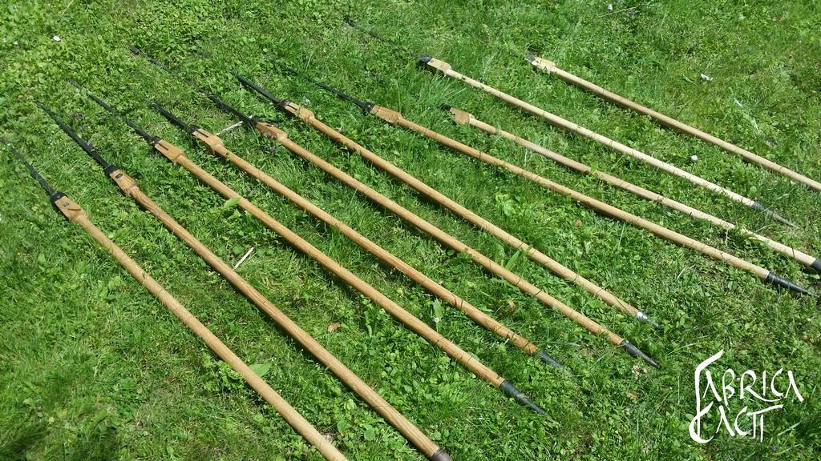

* Contact Fabrica Cacti on Facebook.

**Tier 4: Camping Gear**

*The gear listed in Tier 4 is essential for completing the basic look of the Roman Legionary.*

**Required items:**

* Furca
* Waterskin/Gourd
* Mess Gear
* Leather sack
* Pera/Camachio Bag

**Furca**

*The Furca is simply a ‘t’ or cross shaped item made of two pieces of wood, used to carry non-worn items.*

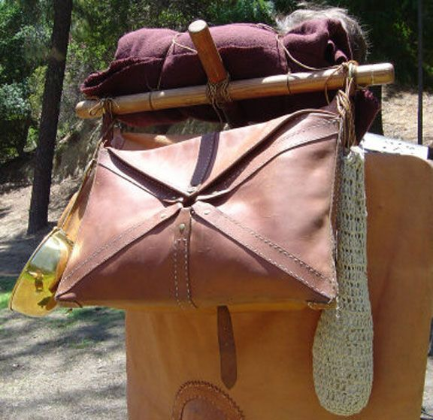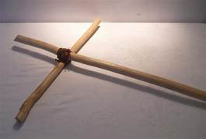

**Waterskin/Bottle/Gourd**

*A leather waterbottle or water skin can be purchased at a cost of between $40 to $60. Best vendor is Fabrica Cacti. Gourd canteens can be made, or purchased from several vendors.*

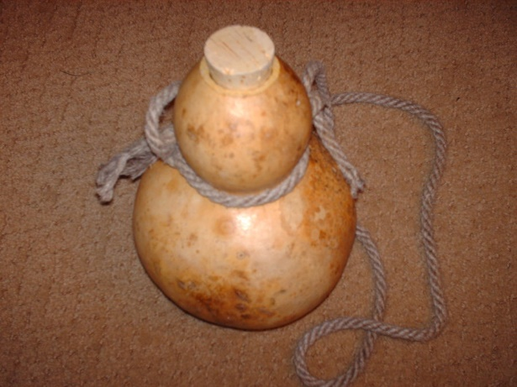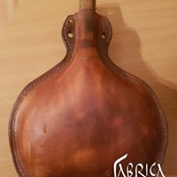

**MESS GEAR**

*Your mess gear is comprised of a simple wooded plate and bowl, a Tinned Patera (brass pot with handle, tined lining) and a wooden or brass spoon and a small knife. All of these items can be purchased from vendors. Soul of the Warrior often has package deals for these items.*

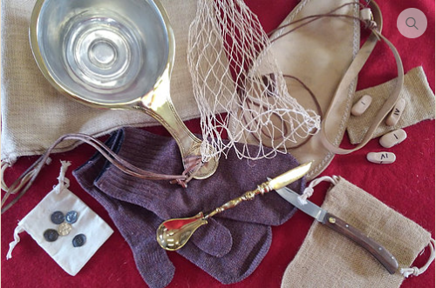

* This can be ordered in bulk from Soul of the Warrior. Please contact them through their website, and state that you need Roman Camping Gear.
  + <https://www.soulofthewarrior.com/>

*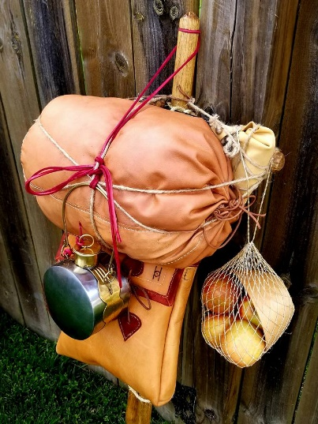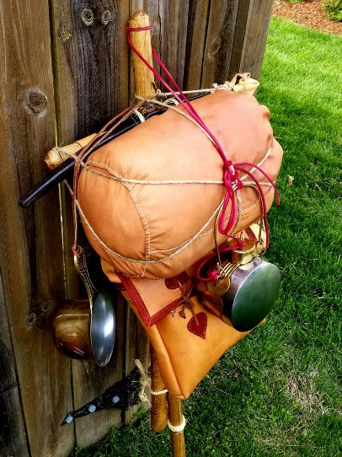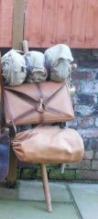***LEATHER SACK, PERA OR CAMACHIO BAG***The leather sack is a small leather duffle bag used to protect and carry items such as your blanket or cloak. The Pera or Camachio bag is a leather bag worn with a shoulder strap, or attached to your Furca. Both of these can be seen in the pictures below, of a Furca with items attached. Fabrica Cacti or Sadlers Den are both great vendors for these items.*