Legio XIIII Gemina
Auxiliary Slingers
Handbook

A Legio XIIII Guide: Auxiliary Slinger Kit

  - This guide will allow beginners to start their impression on a budget. Included are options to add to the impression, and evolve it into a Roman Auxiliary.

Tier 1: Soft Kit
What makes slingers an excellent ranged unit is their versatility. Slings cost almost nothing to make, and can turn something as small as a pebble into a lethal weapon. Slingers can also carry shields, to defend against return fire, something archers cannot do, while outranging javelin-men.

Required items:
- Tunic
- Shoes
- Sling
- Belt
- Cloak
- Optional Items: Trousers

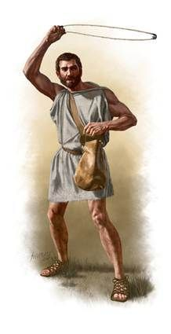

Tunic
Slinger clothing follows two distinct styles, Northern and Mediterranean. Mediterranean Slingers, like the Balearic and Rhodian Slingers, wore loose sleeveless tunics much like the Romans. Northern slingers, like those from Gaul and Britain, wore warmer, form-fitting clothing with more coverage.
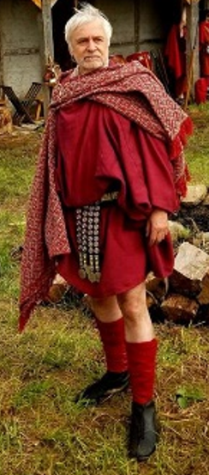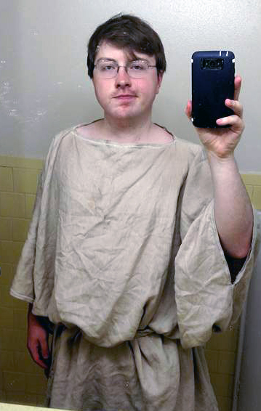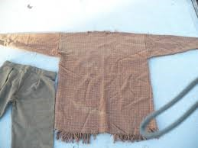
- Materials Needed: $40-58+shipping
  - 3-4 yards natural linen: $30-$40+shipping (Can also be found at local fabric stores).
    - https://fabrics-store.com/fabrics/linen-fabric-IL019-natural-middle/
    - Subdued earth tones (brown, green, ochre, etc) are also acceptable.
    - Blue should be light blue, to mimic woad-based dyes.
    - Discount Code: ILOVELINEN
  - OR 3-4 yards natural wool: $36-48+shipping.
    - https://96fabrics.vendecommerce.com/p/tan-wool
    - Subdued earth tones (brown, green, ochre, etc) are also acceptable.
    - Blue should be light blue, to mimic woad-based dyes.
  - Needle Pack: $3.99+shipping
    - https://www.tandyleather.com/en/product/stitching-needles
  - Linen Thread: $6.99+shipping
    - https://www.tandyleather.com/en/product/unwaxed-linen-thread-natural
  - NOTES:
    - Please use one of the patterns below:
    - We prefer you hand stitch your garments. The thickness of linen thread makes them more resistant to tears than machine thread.
      - You may use a sewing machine if you want, but please use a straight stitch.
Northern Tunic Pattern:
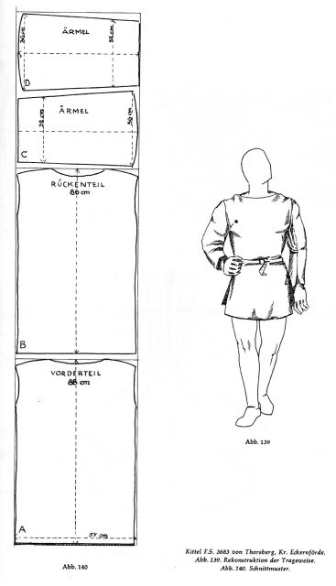

Mediterranean Tunic Patterns:
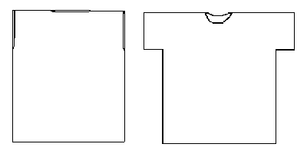

Trousers (Optional)
Though considered effeminate by the Romans, trousers are necessary in the colder northern climates, and a staple of central/northern European cultures. These could be made of wool, linen, or leather.
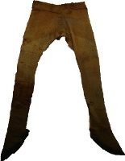
- Materials Needed: $30-$40+shipping
  - 2 yards natural linen: $20+shipping.
    - https://fabrics-store.com/fabrics/linen-fabric-IL019-natural-middle/
    - Subdued earth tones (brown, green, ochre, etc) are also acceptable.
    - Blue should be light blue, to mimic woad-based dyes.
    - Discount Code: ILOVELINEN
  - OR 2 yards natural wool: $15-30+shipping.
    - http://www.96fabrics.net/products/dark-brown-wool
    - Subdued earth tones (brown, green, ochre, etc) are also acceptable.
    - Blue should be light blue, to mimic woad-based dyes.
  - Needle Pack: $3.99+shipping
    - https://www.tandyleather.com/en/product/stitching-needles
  - Linen Thread: $6.99+shipping
    - https://www.tandyleather.com/en/product/unwaxed-linen-thread-natural
  - NOTES:
    - Please use the pattern below:
    - We prefer you hand stitch your garments. The thickness of linen thread makes them more resistant to tears than machine thread.
      - You may use a sewing machine if you want, but please use a straight stitch.

Northern Trousers
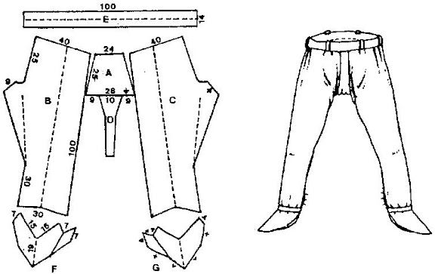
Mediterranean Trousers
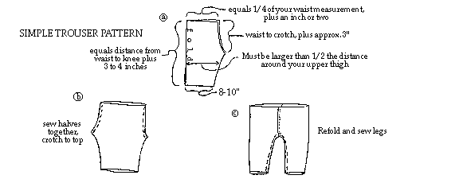

Sling
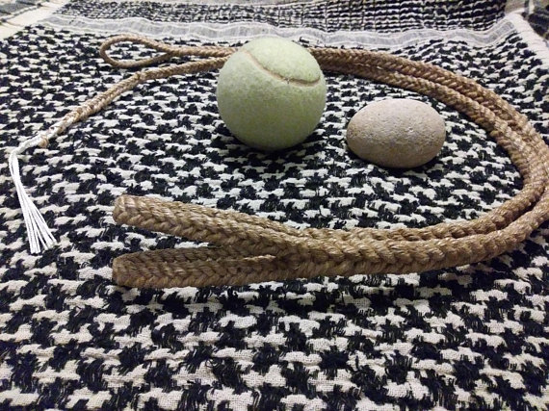
- Order a sling from the link below:
  - https://www.etsy.com/listing/593042702/balearic-sling?gpla=1&gao=1&&utm_source=google&utm_medium=cpc&utm_campaign=shopping_us_a-craft_supplies_and_tools-tools_and_equipment-tools-other&utm_custom1=29ce1667-4faa-41fe-a97a-1f1bda515153&gclid=CjwKCAjw14rbBRB3EiwAKeoG_5c2YjklJc-twy_ZlIWRuy2iKxFSCjIaA81qRP1BiiJa8c-fvof6fRoCVPsQAvD_BwE

Caligae
Though shoe style would have varied, for auxiliaries, shoes would have been compensated at the expense of the Roman state.
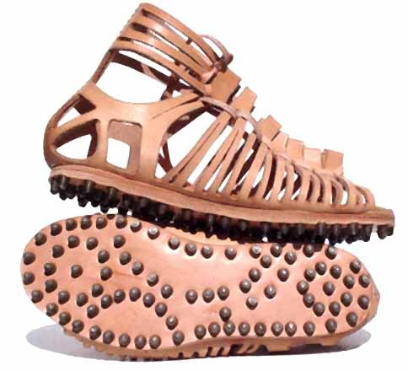
- Use one of the below sources to order caligae. Sandal sizes differ from standard shoe sizes, so order 1-2 sizes below your normal shoe size.
  - http://www.kultofathena.com/product.asp?item=GB0904&name=Roman+Caligae+Sandals+-+Dark+Brown
  - https://www.soulofthewarrior.com/product-page/castleford-caligae
  - For High Quality Caligae, order here:
    - https://www.facebook.com/FabricaCacti/

Cloak
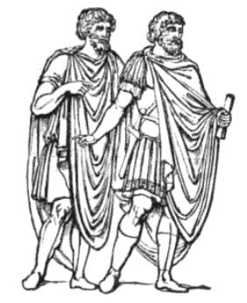
- Materials Needed:
  - 4 yards natural wool: $92+shipping.
    - http://www.96fabrics.net/products/dark-brown-wool
    - Subdued earth tones (brown, green, ochre, etc) are also acceptable.
    - Blue should be light blue, to mimic woad-based dyes.

Brooch
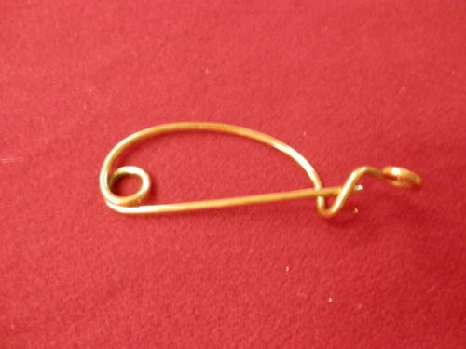
- Sold on Soul of the Warrior’s Ebay Page: https://www.ebay.com/itm/Ancient-Reenactor-Pin-Fibulae-blanket-pin/232850213929

Tier 2: Hard Kit

Required items:
- Tunic
- Shoes
- Sling
- Shield
- Belt
- Cloak
- Optional Items: Pugio, Trousers

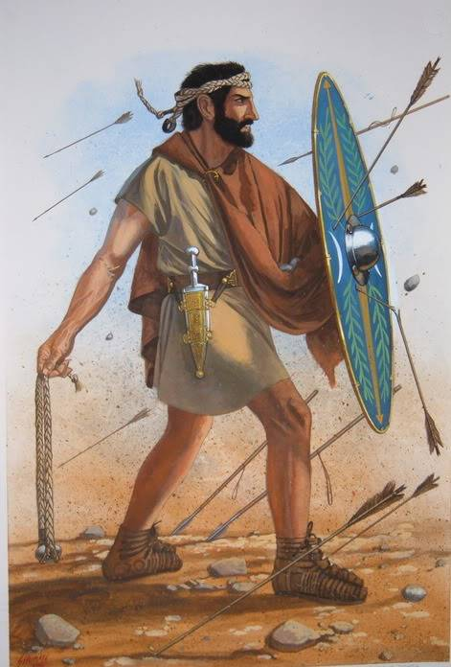

Shield (Use one of the patterns below):
Armor was not as common in Britain as it was in Rome, during this time period. Therefore, a good shield was necessary for maximum protection in battle. Brythonic shields were flat, often cut in oval patterns, some with concave edges.
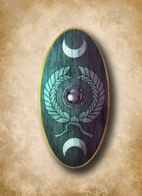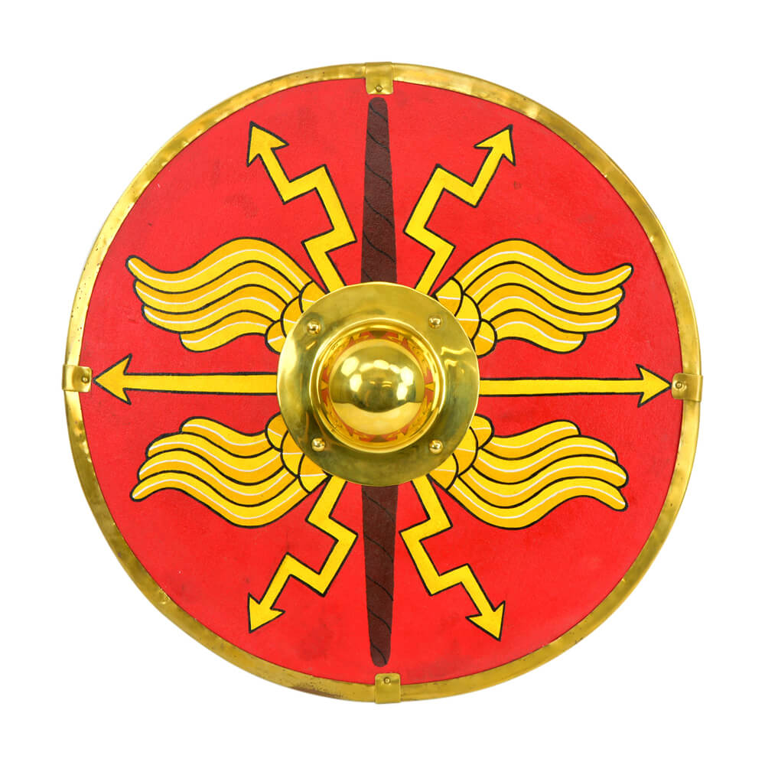
- Materials Needed: $91.49+shipping
  - 2 5mm Wood Panels 24” x 48”: $7.99 Each
    - Found at Local Home Depot
  - 2 yards natural linen: $20+shipping.
    - https://fabrics-store.com/fabrics/linen-fabric-IL019-natural-middle/
    - Subdued earth tones (brown, green, ochre, etc) are also acceptable.
    - Blue should be light blue, to mimic woad-based dyes.
    - Discount Code: ILOVELINEN
  - Shield Boss: $16.89+shipping
    - http://www.kultofathena.com/product.asp?item=SNS2197&name=Conical+Shield+Boss+-+16+Gauge+Steel
  - Rawhide Dog Bone: $5.59+shipping
    - https://www.chewy.com/pure-simple-pet-flat-knotted-rawhide/dp/154808
  - Copper Nails: $12.06+shipping
    - https://www.amazon.com/Hillman-Fastener-Corp-42081-Copper/dp/B000RMRQA8/ref=sr_1_4?s=hi&ie=UTF8&qid=1531880248&sr=1-4&keywords=copper+nails
  - Needle Pack: $3.99+shipping
    - https://www.tandyleather.com/en/product/stitching-needles
  - Linen Thread: $6.99+shipping
    - https://www.tandyleather.com/en/product/unwaxed-linen-thread-natural
  - Wood Glue: $9.99+shipping
    - https://www.amazon.com/Titebond-Premium-Water-Resistant-Wood/dp/B001DSZ2RY/ref=sr_1_2?s=hi&ie=UTF8&qid=1531880327&sr=1-2&keywords=titebond+wood+glue
  - NOTES:
    - Please use the guide below.
    - It is not necessary for you to buy a needle/thread set for each listing. This just lists what you need to craft the item and its cost, but you get a lot of needles and thread per order.
- Shield Construction Guide
  - Glue boards together and clamp for 12 hours.
  - Cut desired shape out, drill out semi-circles for grip.
    - Use excess wood to thicken grip.
    - Sand/grind edges for comfort, as needed.
  - Grind grip down into a rounded shape.
    - Horseshoe Rasps are best for this.
  - Use wood core as template to measure/cut out linen hex shapes.
  - Glue linen over wood core. Cut linen that overlaps grip. Let sit for a few hours.
  - Take dog bone and soak in hot water until unraveled. Cut out 3” wide strips from rawhide, and while wet, glue to shield edges.
    - Put glue along shield edge first.
  - Let dry until hardened.
  - Use 1/8” drillbit to drill holes in rawhide approx. ½” apart.
  - Use linen/thread to run single or double stitch through holes to secure rawhide.
  - Paint (or don’t) as desired with old fashioned milk paint.
    - www.woodcraft.com

Pugio
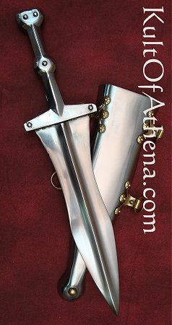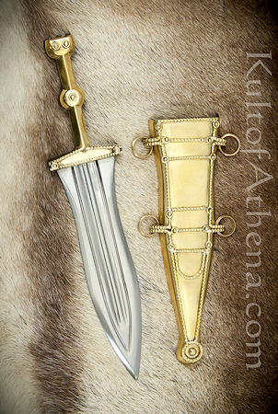
- Plain Pugio
  - http://www.kultofathena.com/product.asp?item=AH3264P&name=Roman+Pugio
- Leeuwen Pugio
  - http://www.kultofathena.com/product.asp?item=AH3264A&name=Leeuwen+Pugio+Dagger

Balteus
The status symbol of all Roman soldiers, many denarii went into stylizing the Balteus. It was the key piece of military fashion during the first century.

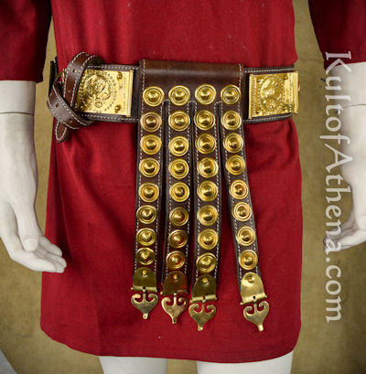

- Purchase here: http://www.kultofathena.com/product.asp?item=AH6797&name=Roman+Cingulum+Belt+-+%27%27She-Wolf%27%27+with+Romulus+and+Remus
- A simpler version of this can be made with a belt buckle and a leather strap (50” x 1.5”) from Trinity Armory (Contact Jason R. Young)

